Chapter 19
Plant Defenses

Introduction

Most plants are sessile organisms affixed to an immobile substrate. Plants usually have the ability of movement, as occurs when a leaf tracks the movement of the sun through the day (phototropism) or a root orients its growth downward (gravitropism). However, such movements are insufficient to evade predators or pathogens. Instead plants rely on a variety of other mechanisms to prevent and reduce herbivory and disease. Plant defenses begin first with physical structures. If these are overcome a litany of chemical protection provides a vast arsenal with which to mount counterattacks. While plant immune defenses are much different than animals, they do have reactive immune systems which share some of the same mechanisms as our own. We will discuss some of these features in this chapter, beginning with physical structures, then moving on to summarize chemical defenses and reactive plant immunity as they occur in pattern- and effector- triggered immunity (PTI and ETI) systemic acquired resistance (SAR) and induced systemic resistance (ISR)

Physical Defenses
All plants have cell walls, which give them structure and protect them from external threats. However, because they can’t move like animals, plants have evolved other strategies to fend off predators and pathogens. The first line of defense is physical barriers, much like how our skin protects us. For example, woody plants have bark, which functions like a shield. On plant parts without bark, like leaves, a waxy cuticle on the epidermis helps protect against both abiotic and biotic stressors.
Table 19.1. Trichome types found on Cannabis
Type |  | Approximate sizes | Features
Non-glandular | Non-cystolithic | 70-125 μm | Thin, unbranched, simple in shape. Unicellular. Occur most densely on the underside of leaves and bracts.
 | Cystolithic | 250-370μm | Similar to non-cystolithic in shape, but larger. Contains cystoliths, calcified outgrowths of the cell wall, at their base.
Glandular | Bulbous | 10-30 μm | Diminutive trichome with secretory cells. Variable structure.
 | Capitate sessile | 25-100 μm | Large glandular head with secretory cells often attached by several cells, but only one cell high.
 | Capitate-stalked | 70-150 μm, stalk up to 1000 μm | Large glandular head with secretory cells situated on top of a slender, multicellular stalk.
 | Antherial Sessil | 25-100 μm | Occur only on the anthers and calyx of male flowers.

Plants also have trichomes, tiny hair-like structures that are especially abundant in Cannabis (Table 1, Fig 1). Trichomes have several roles, including reducing water loss, shading leaves from intense light, deterring herbivores, and even secreting chemicals that defend the plant. Cannabis produces at least three types of trichomes, which contain cannabinoids, terpenes, acids, and polyphenols. The types and sizes of trichomes vary depending on the plant's genotype and age.
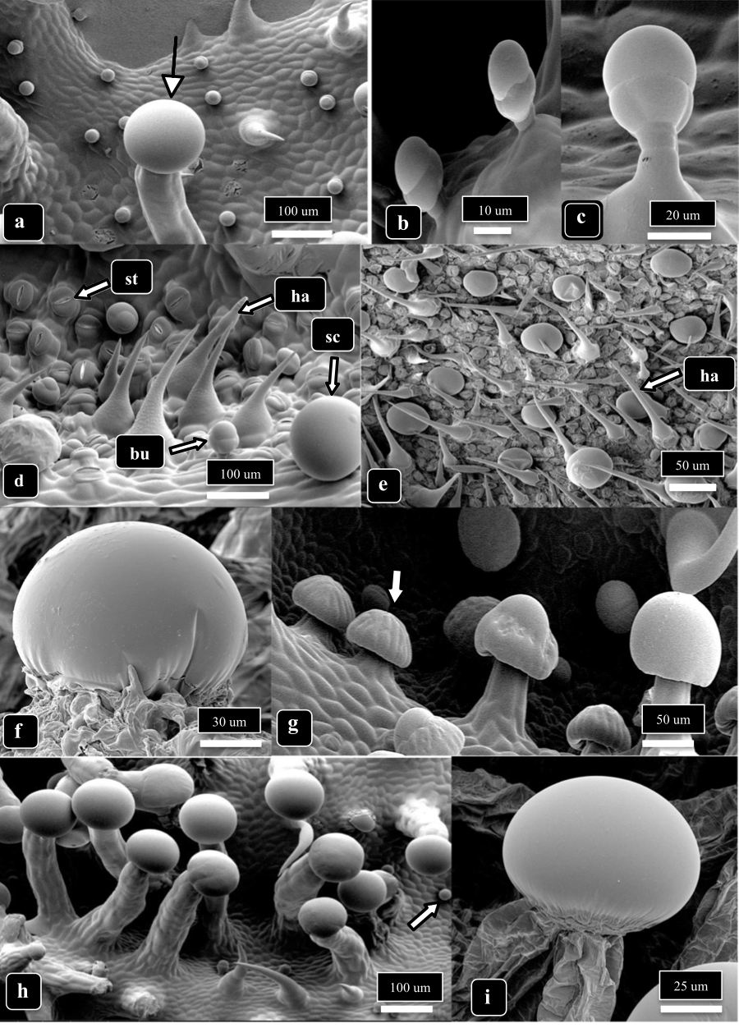
Fig 1. Scanning Electron Micrograph (SEM) showing different types of trichomes Cannabis plants can produce. The arrow in a) is pointing to a stalked capitate trichome, b) & c) are showing bulbous trichomes, images d) & e) show bulbous (bu) non-glandular (ha) and sessile capitate (sc) trichomes as well as leaf stomata (st), f) is a zoomed-in image of a sessile-capitate trichome, the arrow in g) is pointing to a presecretory sessile capitate trichome with stalked-capitate trichomes to the right, the arrow in image h) points to a small bulbous trichome and stalked-capitate trichomes to the left, and image i) is a close up of the head of a stalked-capitate trichome. From Punja et al 2023.
Internally, plant cells have a selectively permeable plasma membrane surrounded by a cell wall made of lignin, cellulose, and xylan. Roots also have a specialized internal barrier called the Casparian strip, which ensures that water must pass through the plasma membrane of cells before entering the vascular tissue to be transported throughout the plant. This selective permeability helps plants exclude large molecules and potential pathogens unless specific transport channels allow entry.
Stomata, the openings on the plant surface that allow for gas exchange, are another vulnerable point for infection. Fungi, for example, often target stomata by forming an appressorium, which allows them to bypass the leaf cuticle and epidermis to enter the plant (Fig. 3). Similarly, root hairs are commonly targeted by microbes as an entry point.

Chemical Defenses
Plants produce a variety of secondary metabolites, which are chemicals not directly involved in the plant's normal growth processes but are crucial for defense. These include terpenes, phenolics, alkaloids, phytoalexins, defensins, and enzymes. Secondary metabolites play a significant role in plant health by mediating interactions with microbes and defending against both microbial and animal attacks.
Phytoalexins are a class of secondary metabolites produced or activated only after contact with a pathogen. While the term "phytoalexins" is sometimes used to refer to all plant defense chemicals, true phytoalexins are only produced after infection, unlike chemicals that are present pre-infection. An ongoing effort to categorize the wide variety of phytoalexins and plant defense chemicals is summarized in Table 19.2.
Table 19.2. Chemical defenses of plants involved in microbial defenses.

Non-Nitrogen Containing | Terpenes/Terpenoids  Flavonoids  Lignans  Phenylpropanoids  Coumarins  Tannins  Steroids  Saponins  Polyacetylenes  Fatty acids
Nitrogen Containing | Alkaloids  Non-protein amino acids  Amines  Alkamides  Lectins  Peptides  Polypeptides  Enzymes  Defensins  Small interfering RNAs  Nucleic acid extracellular traps

Plant Immunity
While plants lack an adaptive immune response like animals, they are far from defenseless. Plants have innate immune systems that allow them to respond to pathogens and pests by altering their growth and ramping up their chemical defenses. When triggered, plants can activate an immune response that affects the whole plant.
Depending on the trigger, the immune response can be either induced systemic resistance (ISR) or systemic acquired resistance (SAR). ISR is typically a milder response, often triggered by interactions with beneficial microbes like Rhizobia or mycorrhizae. On the other hand, SAR is a stronger response that is usually triggered by a pathogenic attack. Both ISR and SAR prime the plant's immune system, preparing it to better defend against future threats.
Plants recognize invaders through two main immune responses: pattern-triggered immunity (PTI) and effector-triggered immunity (ETI). These responses are critical for detecting and fighting off pathogens. You can find more details on these systems in Table 3, where we list key abbreviations and terms related to plant immunity.
Table 19.3. Abbreviations of commonly encountered terms when discussing plant immune responses.

ISR | Induced Systemic Resistance
SAR | Systemic Acquired Resistance
PTI | Pattern Triggered Immunity (aka Basal Immunity)
ETI | Effector Triggered Immunity
MAMPs | Microbe-Associated Molecular Patterns
DAMPs | Damage-Associated Molecular Patterns
NAMPs | Nematode-Associated Molecular Patterns
PAMPS | Pathogen-Associated Molecular Patterns
PGPR | Plant Growth Promoting Rhizobacteria
PR-proteins | Pathogenesis-Related proteins
ROS | Reactive Oxygen Species
R-genes | Resistance genes involved in ETI, most often of the nucleotide binding, leucine rich repeat (NB-LRR) or pattern recognition receptor protein (PRR) classes

In short, plants have evolved a complex and multi-layered system of defense to protect themselves from predators, pathogens, and environmental stressors. From physical barriers like bark and trichomes to sophisticated chemical responses and immune signaling pathways, plants use a variety of strategies to ensure their survival and fitness.
Systemic Acquired Resistance (SAR) and Induced Systemic Resistance (ISR) are two ways plants boost their defenses when under attack by pathogens or pests, and both rely on different pathways to get the job done.
ISR typically kicks in when a plant's pattern-triggered immunity (PTI) is activated. This response is mainly driven by plant hormones like jasmonate and ethylene. On the other hand, SAR is tied to effector-triggered immunity (ETI) and involves a different set of hormones, primarily salicylic acid. While both ISR and SAR help plants defend themselves, they’re triggered by different conditions and involve slightly different processes, though they do share some overlapping effects.
For example, SAR is associated with the production of pathogenesis-related (PR) proteins and a hypersensitive response, where cells around the infected area undergo programmed cell death to prevent the spread of the pathogen. ISR, on the other hand, doesn’t produce these PR proteins. But both ISR and SAR activate the production of callose, a substance that strengthens cell walls and helps stop pathogens from spreading throughout the plant.
Interestingly, ISR can be triggered by beneficial bacteria (like plant growth-promoting rhizobacteria), which was actually how ISR was first discovered. And while ISR and SAR are distinct, they share enough similarities that both help reduce disease and pest severity across the entire plant.
Table 19.4. Features of SAR and ISR
Systemic acquired resistance | Induced systemic resistance
- Triggered by biotic and abiotic stressors (MAMPs/DAMPs/Abiotic)  - Hypersensitive response- Localized Reactive oxygen species (ROS) burst causes host cell death around area of infection  - Pathogenesis-related proteins (PR-proteins) accumulate  - Callose production | - Salicylic acid ‘independent’  - Mediated by jasmonate/ethylene signal transduction  - Triggered by biotic inducers (MAMPs)  - Callose production

Breeders can take advantage of these natural defense mechanisms by selecting plants with stronger innate immune systems. Through breeding, they can create plants with genetic traits that enhance their ability to fight off diseases and pests, giving them a better chance of surviving in the wild.
In summary:

- Plants have evolved defense strategies to protect themselves from potential pathogens including physical and chemical mechanisms
- Plant immune system includes Induced Systemic Resistance (ISR) and Systemic Acquired Resistance (SAR)
- Depending on what triggers the plant immune response the plant may produce chemicals intracellularly or extracellularly
- Immune response increase the plants ability to defend itself against pathogens

